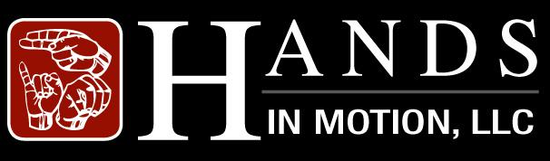

45 Victoria Drive
Ellenwood, Georgia 30294
404-932-9404

We are Hands in Motion, LLC, a sign language interpreting agency currently serving Atlanta, Georgia. We are introducing our nonprofit Reach One, Teach One to the West Coast. Our mission is to teach families, where there is a deaf or hard of hearing individual residing, sign language. Communication is essential and without it frustrations occur, in and outside of the home. We plan to teach with products that we produce ourselves such as: DVD’s, dictionaries, flashcards, and other tools needed to help us be successful in our mission.

We are in the process of organizing and presenting an event that will raise funds for a valuable new community project that we are embarking on. We appreciate all you do and would love to extend an invitation to be among one of this year’s sponsors. This letter to ask for your support and sponsorship for our third annual “Signing the Night Away”, a Program to Benefit Reach One, Teach One. This event will be an 18 and older affair for mature audiences only.

“Signing the Night Away” will feature invited guests from the entertainment and art worlds; we will be offering vendor spaces and distributing flyers announcing the event starting months prior to the event. T-shirts will also be given away and sold the night of the event. Community activists and neighborhood advocates will be featured as well as prominent comedians from the Los Angeles area will be performing, with a variety of musical performances, including special guests.

“Signing the Night Away” will allow us to raise enough money to be able to provide a place and materials needed to provide educational services to families of Deaf and Hard-of-Hearing individuals. Our wish is to finance this endeavor at its fledgling phase. In working in this culture, too often we encounter families who are unable to communicate with their Deaf and Hard-of Hearing family members, due to the lack of essential communicational skills. This event will allow us to continue on our mission to remedy this distressing situation.

One of our main focuses is the youth, and because our first two events drew massive attention to such a diverse group of individuals of all ages; we have decided to host a separate event for our younger audience members. This year we are introducing “Signing the Day Away”, a daytime event that will feature music, storytelling, magicians, and other activities for toddlers to young adults. We look forward to this event, as it will include and allow the younger generation the opportunity to experience this historical event.

Net proceeds of “Signing the Night Away” will be used to further the work of ROTO, including the provision of ASL dictionaries, instructional video tapes and other materials that will be indispensible in the accomplishment of our mission. I am petitioning for your support of this grand event.

You and other representatives of your organization would be heartedly welcome to attend “Signing the Night Away” so that we can avail an opportunity to thank you personally for your support.

Our expected estimated audience of 500-1,000 would benefit terrifically from your generosity. The cost to sponsors is delineated on the following page. I would be most enthusiastic to talk you personally regarding your interest. You can contact me at (404) 932-9404. I am looking forward to hearing positive views from you.

Thank you for considering this request.

Marsha Coles-Felix
Hand in Motion, LLC
Handsinmotionllc.net
Handsinmotion2008@yahoo.com

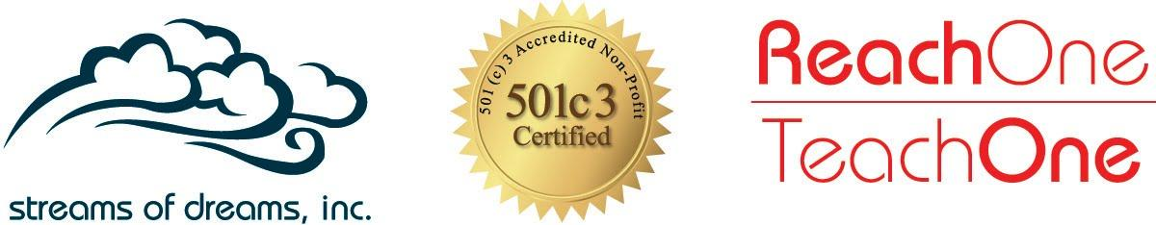

Prestigious Sponsorship
$5,000 or Greater
For your prestigious level sponsorship, you will receive:

- Your name or company’s name mentioned during the event with a brief description
- Your generous sponsorship noted in program
- Free booth space to display products or services
- Five (5) All Access VIP Tickets
- $100 Voucher
- Table For Five (5)
- Walk The Red Carpet

Platinum Sponsorship
$2,000 - $5,000
For your platinum level sponsorship, you will receive:

- Your name or company’s name mentioned during the event with a brief description
- Your generous sponsorship noted in the program
- Free booth space to display products or services
- Two (2) All Access VIP Tickets
- $50 Voucher
- Table For Four (4)
- Walk The Red Carpet

Gold Sponsorship
$1,000 - $2,000
For your gold level sponsorship, you will receive:

- Your name or company’s name mentioned during the event
- Your generous sponsorship noted in the program
- Free booth space to display products or services
- Table For Two (2)
- $25 Voucher
- Walk The Red Carpet

Silver Sponsorship
$500 - $1,000
For your silver level sponsorship, you will receive:

- Your company’s name mentioned during the event
- Your generous sponsorship noted in the program
- Free booth space to display products or services
- Table For Two (2)
- Walk The Red Carpet

